Blog June 2014

WHAT’S STOPS YOU WITH A LOW CARB LIFESTYLE? INCONVENIENCE?
6/22/2014
0 COMMENTS

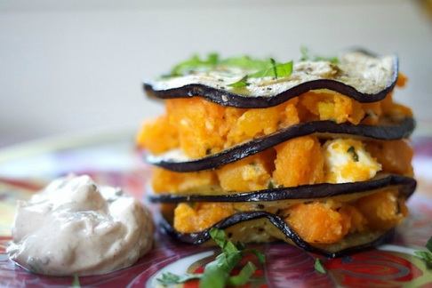A layered sandwich with a difference
Life with little or no bread and cakes can be difficult at first; no, it’s not so much fighting the addictive effects of the wheat or the comfort of sweet chocolate bars, it’s the plain inconvenience.
Just taking a look at the counter at Costa where I get my regular cappuccino reveals nothing at all that does not contain refined carbohydrates and sugar. And lunchtime morsels are so much easier to eat when served between two slices of bread. You don’t even need a napkin to wipe your hands thanks to the soft but damp-resistant processed bread which takes care of that. And that’s just how John Montagu, the 4th Earl of Sandwich intended things to be when he ‘invented’ the sandwich back in 1762 - it was to allow him to eat and play cards at the same time!
So even if you buy into the logical arguments in favour of LCHF, I have to admit that it takes effort, determination and a degree of daily preparation to go ahead.
Salads in a jar are a great way to go, but there is preparation involved and contrary to a sandwich, you’ll need at least a fork to eat it with. Lettuce wraps are another way to go; English style cheese and pickle wrapped in a lettuce leaf tastes great for example.
Some people go for a reduced half-way house approach if they get caught short. Burger King for example put sauce on top of the burger so you can take the bottom half of the bun away without things getting too messy. And Big Macs really don’t need the third slice of bread in the middle. Take it away! Even better, ask for a naked burger; more and more burger joints offer a lettuce wrap alternative mostly to cope with the growing gluten-free situation.
There’s a useful Buzzfeed article entitled 15 No-Bread Sandwiches which is a good source of ideas:http://www.buzzfeed.com/ailbhemalone/15-mouthwatering-no-bread-sandwiches
Or… back to being prepared. Make your own flax wraps courtesy of Dr William Davis’ recipe.
Ingredients
3 Tbsp ground flaxseed
1/4 tsp baking powder
1 Tbsp coconut oil
1 large egg
1 Tbsp water
Directions
Mix together flax and baking powder. Stir in melted coconut oil. Beat in egg and water until blended. Pour into greased microwave safe pie plate. Microwave on high for 2-3 minutes until cooked. Allow to cool for about 5 minutes. Gently lift an edge with a spatula, loosen from the pan. Flip the wrap over and top with desired toppings.

0 Comments

WHERE TO GET YOUR LCHF DIET IN SOUTH AFRICA - AT A PRICE!
6/14/2014
0 COMMENTS

June 2014:
The African Pride Crystal Towers Hotel & Spa has become the first hotel to work with international sports science expert and Original Eating proponent Professor Tim Noakes to create an additional conferencing menu for the many thousands of executives who choose to follow a healthier LCHF diet.
Danny Bryer, Director of Sales, Marketing and Revenue for African Pride Hotels, says the property is Cape Town’s premier conferencing hotel and healthier eating is something guests want. “Of course we’ve listened and at the end of this exercise we’ll be able to offer low carb conference dishes that fit comfortably into an Original Eating plan.”
Says GM Carolyn Jones: “This is indicative of an increase in health and diet awareness among conference attendees and in broader society. Conference snacks and meals have traditionally been starch and sugar based, but as more people become aware of the impact of diet on their health, hotels and other conferencing venues will have to stop relying on the old catering styles.”
According to Dr Larry Distiller of the Centre for Diabetes and Endocrinology in Johannesburg, diabetes is on the rise in South Africa, with 6% of the population suffering from the illness, and more diagnoses being made every day.
Experts name our westernised diet as the main culprit in this worrying trend, with a diet high in sugar and refined carbohydrates, lack of exercise and obesity as the main risk factors for developing type 2 diabetes.
Excerpts from the press release:
http://www.africanpridehotels.com/pressroom/Pages/african-pride-crystal-towers-hotel-spa-welcomes-prof-tim-noakes-to-the-conference-table.aspx

0 Comments

SALAD IN A JAR
6/13/2014
0 COMMENTS

Put together your favourite salad items and a tasty dressing
Sometimes, fast-food can be fun, although here, you need to prepare it in advance before you leave home.
Summer is salad time after all so why not try to compose your own salad in a jar.
It's creative and provides a feast for the eyes too.
Much more at: http://www.fatisourfriend.com/simply-salad-in-a-jar.html

0 Comments

IT'S SAFE TO EAT MORE EGGS - OFFICIAL!
6/11/2014
0 COMMENTS

You'll never find feathers on your eggs in the US but it's common in the EU
The American Heart Association recently increased its egg consumption advice to allow one egg per day, but similar groups in the UK have not done the same. The British Heart Foundation still says you should only have between two and four eggs every week… all a legacy of the supposed egg/cholesterol/clogged artery theories which have now largely been debunked.
But when it comes to eggs, the standard European ones ( everyday supermarket eggs I mean) taste richer than American ones. The yolks are more orange, a bit fresher and have more flavour than American factory farm eggs. In fact; European eggs are so different from American ones that the sale of American eggs would actually be illegal in Europe.
In the U.S., eggs must be washed in order to be sold commercially. In Europe, however, eggs must not be cleaned and this is why eggs may even have the occasional feather garnish. “Not washing the eggs encourages good cultivation on farms”, says Mark Williams, Chief Executive of the British Egg Industry Council.
But the US Dairy Association doesn't see it that way. They're concerned with faecal matter making it from the farm onto the egg, potentially transferring micro-organisms into the egg. The eggs have to be washed in water at a minimum of 32°C before being sprayed with a chemical sanitizer and dried. There is also a thin layer called the cuticle that naturally protects the egg, and EU regulations prohibit the cleaning of eggs in order to keep that cuticle intact.
That’s also why eggs are kept in the refrigerated sections of US supermarkets. Keeping eggs below 6°C decreases the risk of Salmonella, but in the UK, farmers have been vaccinating most of their hens against salmonella since the 1990s, mostly because they want the little red lion stamp on their eggs (about 85% of the UK total). The Lion Quality vaccination scheme is generally used across all methods of egg production, from intensive farming where hens are kept in cages, to free range farms where the hens can roam where they like.
So should I go organic? Eating organic eggs means you will also be eating eggs free from drugs and other chemicals. A concerning report by the UK Soil Association in August last year found that 20% of chicken meat and 10 per cent of eggs contained drugs 'that are not fit for human consumption'. One of those drugs, the antimicrobial agent nicarbazin, has never been tested for human safety but causes birth defects and hormonal problems in animals.
The answer is yes; buying organic or fresh farm eggs in Europe is the best way to go, but whatever eggs you are buying, they’ll taste better than those on sale in the US.In summary, eggs are a very well balanced food for humans. You’ll get slightly more protein than fat and virtually no carbohydrates, together with vitamins, minerals and even unique antioxidants that protect the eyes. They are also a great source of Choline, an important nutrient for the health of the brain which most of us don’t get enough of.
When it comes to dieting; eating eggs for breakfast is likely to lead to significant weight loss compared to eating bagels, toast or cereals. But please, please eat the 'fatty' yolk as well as the protein rich egg-white. It's only through the consumption of healthy fats that our bodies absorb all the healthy nutrients in this and other food.
This story based in part on: http://www.forbes.com/sites/nadiaarumugam/2012/10/25/why-american-eggs-would-be-illegal-in-a-british-supermarket-and-vice-versa/

0 Comments

THE ECONOMIST AND A BIG FAT SURPRISE
6/2/2014
0 COMMENTS

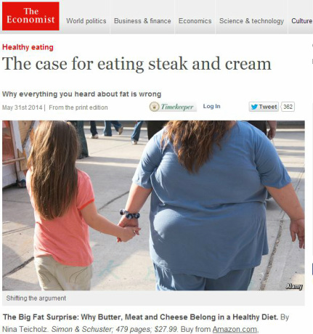Why everything you heard about fat is wrong
It's not often that you'll find The Economist mentioned as a source of dietary advice on these pages but every now and then, a book comes out with such as strong message that even The Economist chooses to effectively endorse it through a book review.
One such book is "The Big Fat Surprise", a brand new publication on healthy eating by the investigative journalist Nina Teicholz.
Nina reveals what for many is still the unthinkable: that everything we thought we knew about dietary fats is wrong. Combining scientific rigour with riveting storytelling, she argues that more, not less fat - including the saturated fats in meat, dairy and eggs - is what leads to better health and weight loss.
In a recently published interview with Dr Frank Lipman, the author tells how her personal journey of discovery started:
"I was a faithful follower of the low-fat, near-vegetarian diet, but when I started writing a restaurant review column, I found myself eating things that had hardly ever before passed my lips: rich meals of pâté, beef, cream sauces and foie gras. To my surprise, I lost the 10 pounds that I hadn’t been able to shake for years, and to boot, my cholesterol levels improved. To understand how this could be possible, I embarked upon what became a decade of research, reexamining nearly every single nutrition study and interviewing most of our top nutrition experts. What I was shocked to find were egregious flaws in the science that has served as the foundation of our national nutrition policy, which for more than 50 years has all but forbidden these delicious and healthy foods."
... back to The Economist, which finishes its review as follows: In the past decade a growing number of studies have questioned the anti-fat orthodoxy. There is increasing evidence that a bigger culprit is most likely insulin, a hormone; insulin levels rise when one eats carbohydrates. Yet even now, with more attention devoted to the dangers posed by sugar, saturated fat remains maligned. “It seems now that what sustains it,” argues Ms Teicholz, “is not so much science as generations of bias and habit.”
Full article at: http://www.economist.com/news/books-and-arts/21602984-why-everything-you-heard-about-fat-wrong-case-eating-steak-and-cream

0 Comments

MEDITERRANEAN DIET WITH HIGH FAT YOGURT LOWERS RISK OF OBESITY
6/1/2014
0 COMMENTS

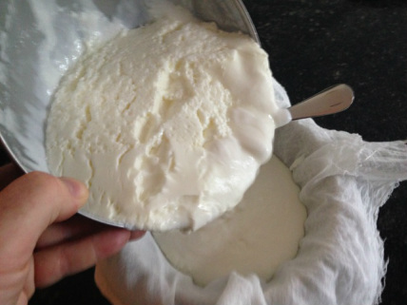Making and straining your own Greek-style yogurt is easier than you think
Based on a large sample of 8,516 men and women, all initially of a healthy weight, Professor Miguel Martinez-Gonzalez of the University of Navarra in Spain, concludes that people who eat full fat yogurt and a rich Mediterranean diet are 36 % less likely to be obese than those who do not eat yogurt often or follow the Mediterranean diet.
When eating a healthy Mediterranean diet, high in fish, vegetables and olive oil, simply eating one pot of yogurt per day makes you 25 % less likely to be obese than those eating two pots a week without the Mediterranean diet.
But those participants eating low fat yogurt did not appear to see any impact on their risk of obesity; possibly because of the extra sugar often added to low fat varieties.
Professor Martinez-Gonzalez said: "Yogurt is just one food and cannot counterbalance an overall unhealthy diet. But for people with good adherence to a Mediterranean diet then yogurt provided an additional benefit. And yogurt also modifies the gut bacteria which can have a beneficial effect on overall health."
The findings, presented last week at the European Congress on Obesity in Sofia, Bulgaria are based on rigorous methods, following up over more than 6 years, during which time 1,860 had became overweight or obese.
The greatest effect of yogurt on obesity was found in people who ate full fat yogurt and a rich Mediterranean diet who were 36% less likely to be obese than those who did not eat yogurt often and did not follow the Mediterranean diet.
A growing number of dietitians are coming round to the idea that feeling satisfied and enjoying your food is better than eating a low fat yogurt, not feeling really satisfied and then snacking on biscuits or chocolate. In this large research study, putting all other factors aside, even just eating full fat yogurt daily was shown to reduce your risk of obesity by nearly a fifth. Another support statement for this website’s mantra – fat is our friend, not our enemy.
A link to diabetes?
This follows on from a similar study published earlier this year which showed that eating a small pot of yoghurt every other day reduces the risk of getting type-2 diabetes by 28%.
The number of people with diabetes in the UK has doubled to more than 3 million in the past 15 years and is forecast to double again in the next decade.
It is of course possible that those who eat yoghurt regularly have simply healthier lifestyles but the researchers suggest that probiotic bacteria and a special form of vitamin K, part of the menaquinone family associated with fermentation of dairy products, may be providing protection against diabetes.

0 Comments

