Blog – April 2014

WHY THE AUSSIES WON THE ASHES - WAS IT DOWN TO THE DIETS?
4/20/2014
0 COMMENTS

From Aussie dietician Peter Brukner's Twitter feed
Let's start with the English team:
Team England sent an 82-page list of their players’ catering demands to each Test match ground during their defence of the famous urn. Andy Flower’s men sent out documents containing nearly 200 different types of meal and beverage ahead of the first Test in Brisbane on Nov 21 2013. The catering options, designed by Chris Rosimus, performance nutritionist of the England and Wales Cricket Board, ranged from “mini mushroom and spinach bhajis” to “quinoa with roasted butternut squash, apricot and parsley”. Here's a snippet from Chris Rosimus' recent interview showing his conventional approach:
Q: What basic nutrition tips for Cricket could you give that are applicable to players of all abilities?
"The most important thing is to make sure you are going into days cricket with some fuel in the tank that provides good quality carbohydrate and lean protein. This will give your body some sustainable energy to help you perform. During the game, drink when you are thirsty and try not to over eat at the lunch and tea breaks. The last thing you want is to feel bloated and full when you've got a heavy spell of bowling to look forward to!"
"At the end of play, have a good meal that provides 1/3 carbohydrate, 1/3 lean protein and 1/3 vegetables or salad. This will help your body recovery to do it all again the next day."
Now compare that to Peter Brukner's simple diet plan for the Australian team. LCHF; which brings, in his words, "better mental clarity". Find out in this lecture what happened to the Australian Cricket team players after adopting that low-carb, high-fat nutritional approach.
https://youtu.be/JMuD4Z-Oxys

0 Comments

HEALTHY DIET MEANS 10 PORTIONS OF FRUIT AND VEG ,DAY, NOT 5
4/14/2014
0 COMMENTS

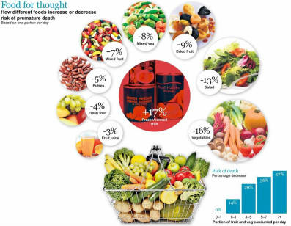
A recent study published by UCL London recommends a doubling of 'five-a-day' diet and finds vegetables to be four times healthier than fruit.
(reported everywhere but these extracts from The Daily Telegraph, 31 March 2014)
A healthy diet should include 10 portions of fruit and vegetables a day, doubling the five-a-day official advice, health experts have said.
The research, which involved a 12-year study, also found that vegetables were four times healthier than fruit. Researchers examined the eating habits of 65,000 people in England between 2001 and 2013.
The study, by University College London, found that eating large quantities of fruit and vegetables significantly lowered the risk of premature death. People who ate at least seven portions of fruit and vegetables each day were 42 per cent less likely to die from any cause over the course of the study.
The researchers also discovered that canned and frozen fruit increased the risk of dying by 17 per cent, and fruit juice was found to have no significant benefit.
The study’s lead author, Dr Oyinlola Oyebode of UCL’s department of epidemiology and public health, said: “The clear message here is that the more fruit and vegetables you eat, the less likely you are to die at any age. My advice would be however much you are eating now, eat more.”
Health experts called on the Government to subsidise the cost of fruit and vegetables, which they suggested could be paid for by taxing sugary foods.
The five-a-day guidelines were based on World Health Organisation recommendations issued in 1990, which advised consuming 400g of fruit and vegetables each day to lower the risk of heart disease, stroke, type 2 diabetes and obesity.
Prof Simon Capewell, of the department of public health at the University of Liverpool, said the advice should be 10 portions a day. “Humans are designed to be omnivorous: a handful of nuts, seeds, fruit and the occasional antelope. We’re not meant to be eating junk food.”

0 Comments

